Environmental Communication and Behaviour
Lecture 1 – Introduction 2
What is pro-environmental behaviour? 2
Pro-environmental communication 4
Lecture 2 – Urgenda Climate Case 7
Lecture 3 – Theories of communication and decision models 7
Lecture 4 – Tabula Rasa 14
Question 1: Problem definition 15
Question 2: Target group analysis 17
Question 3: Behavioural analysis 17
Question 4: Intervention directions 18
Lecture 5 – Acceptance and Resistance 20
Lecture 6 – Developing Environmental Communication 29
Campaign ingredients 29
Communication based intervention techniques 32
Target group segmentation 35
Lecture 7 – Brain, deciding & influencing 41
Working method designing smart measures 44
Lecture 8 – Environmental Communication with groups - Games 48
Individuals, households, groups 48
Group processes 49
Group interventions to change behaviour 51
Q&A 52
Rhetoric 52
Schwartz values 53
Questions: 54

Lecture 1 – Introduction

What is pro-environmental behaviour?
- Behaviour that does not harm environment

What kind of people engage in what kind of behaviour?

Why is individual behaviour important?
- Climate change
- Waste
- Pollution
--> whatever environmental problem you face, there will always be a human aspect to it --> humans will have to make the decision, voting, buying in for your idea, implementing the solution

Can individuals make a difference?
- Individual behaviour adds up (like going voting)
- Individual behaviour changes behaviour of other in their environment
  - network
  - People are social, not fully rational
  - One person starts, others will follow --> example: solar pannels in neighbourhood

Framework: An integral model of individual behaviour in social contexts

- embedded in a social context which consists of different sized groups of other people such as family, colleagues, friends, but also larger groups like neighbourhoods or cities, or even members of the same culture -> sociology models
- material/technological layer that defines behaviour through its context is also taken into account.
- policies and regulations,
- Social practices in that model can be understood as slices of that system. Each practice is a specific behavioural pattern that consists of agents in a social and physical context intergovernance and the economic approach. acting with materials/technologies and in a regulative framework.

Environmental psychology
- Interactions between people and environment
  - how we can understand individual differences in environmental behaviour
  - how to encourage more environmental behaviour.
- Complex interactions

Questions addressed in the field of environmental psychology
- How do people think about Environemtal problems
- What individual difference among people predicts sustainable behaviours?
- How do environmental problems influence individuals well-being ? climate anxiety
- How do groups processes influence sustainable behaviour?
- How can sustainable behaviour be stimulated?

Predictors of pro-environmental behaviour
- Beliefs
  - Thoughts about general classes of objects or issues within a given domain
  - Many people believe climate change is real, human made and has negative consequences, does not necessarily translate into behaviour
  - However, People who believe climate change is real, human-made and has negative consequences:
    - Engage in more climate change mitigation behaviour and support mitigation policy
    - Engage in more adaptive actions and support climate change adaptation policies
- Values
  - Reflect general desirable goals that transcend situations and serve as guiding principles in people lives
  - 4 types
    - Hedonic: satisfaction + improve their feelings and reduce effort (e.g., pleasure, enjoying life)
    - Egoistic: Enhance own resources
    - Biospheric: protect environment + enhance quality
    - Altruistic: ways to increase the welfare of others and benefit society (e.g., equality, helpful)
- Attitudes
  - Mental disposition to evaluate an attitude object with some degree of favour and disfavour
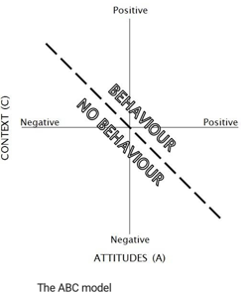
  - Can predict behaviour in some cases (dependent on complexity of behaviour)
  - Attitudes predicts behaviour when behaviour is moderately to very difficult to perform
  - ABC model environmental Behaviour = external Conditions + Attitudes
    - Situational conditions are important make behaviour easy to perform
    - Attitudes are important for behaviours with medium difficulty
    - Examples: climate change should be given top priority; Cycling is a fun activity; I like vegan meat substitutes; I find recycling satisfying

Pro-environmental communication
- Educate and alert people + influence their mindset and behaviour towards more sustainable lifestyles
- Examples: energy saving campaigns, sustainable product advertising, public space sign posts, campaigns targeting unsustainable business practices,
- Forms:
  - Direct communication 2 or more people are present less likely people ignore it, and more likely trust between parties develops
  - Mediated person to person through technological device
  - (Mass) Media one party is the sender of a message, the other the receiver (with other 2 interactive)

Analysing pro-environmental behaviour
- Who was the sender?
- What was the aim or target behaviour of the campaign?
- Who was the target group?

Types of environmental communication
- Direct communication between two or more people when all of them are present at the same situation
- Person- to- person communication between two or more people which is mediated by a technological device
- Via media
  - Less tailored than the other two

The four sides model
suggest each message has 4 facets:
- The Factual Level: statements with fact-like information
- The self-revealing: the message says something about the sender (e.g. their motives, values, emotions etc.)
- The relationship-layer: the message reveals information about the relationship between the sender and receiver
- The wish or want: contains the plea, advice or instruction that the speaker is seeking
Not every message has all these dimensions very clear, but they are often identifiable in some way
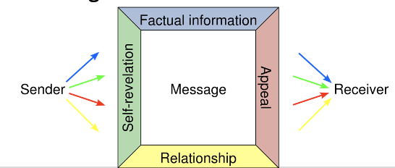

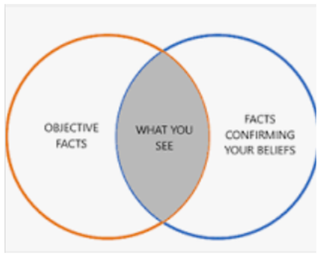
Attention selection processes
Various types of selective processes take place in the development and reception of environmental communication
All attention is selective. The eye can handle 5 million units per sec, the vision centre in the brain 'only' five hundred.
People are biased to select information that which fits their own ideas and opinions and enhances self-esteem.
- the information being Broadcasted
- Cognition/ perception
- Attention not at all parts of the message
- Acceptance for the information heard
- Memory encoding (remember all the information)
- Discussion of the message
--> selective attention tests
  - Depending on the target that you have, you select different types of aspects of the messageIt’s important to consider the structural boundaries of the context in which the behaviour is performed that the target group may experience to change behaviour. It’s important to consider the structural boundaries of the context in which the behaviour is performed that the target group may experience to change behaviour.
  - Keep this in mind when creating the message we want to send

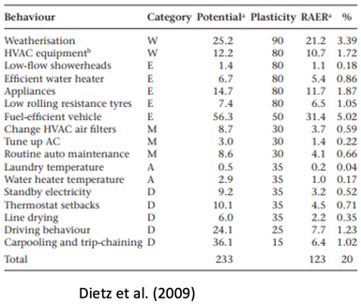
What type of behaviour should be targeted?
- With large environmental impact
- Many people are able to change behaviour
- Many people can perform the behaviour
there is a ranking of potential
individual impact potential = 20%

Structural boundaries:
It’s important to consider the structural boundaries of the context in which the behaviour is performed that the target group may experience to change behaviour.
- Cultural
- Physical
- Economic
- Lack of skills/abilities
when structural boundaries are changed, there is room for environmental communication!
when creating a campaign, consider structural boundaries that might need to be addressed in it

Lecture 2 – Urgenda Climate Case

How to communicate climate change
- Fun vs. Depressing way of delivering arguments what is better?
- Communicate with people that do not know so much about CC
Balance of communication: tell people 1/3 depression + 2/3 solutionn
- if too much depression, then people shut down
- if too much solutions, people say ‘nice story’ but don’t act

Action plan
- identify what’s the biggest issue
- make plan if possible, then go to action
- focus on solutions, identify obstacles and solve them

Lecture 3 – Theories of communication and decision models

Theories
Ipsative Theory of Behaviour Explains why people do not act environmentally friendly
- Objective constraints
= prevents the alternative to be chosen“I want to recycle my plastic, but my municipality does not facilitate waste separation”“I want to buy vegetables without plastic packaging, but the supermarket does not offer it”
- Subjective constraints (focus of most research)
= prevents that an alternative is preferred “It is too expensive, too much hassle, I would stand out too much with my choice”
- Ipsative constraints = prevents an activation of a behavioural alternative
⇒ Most behaviour models focus only on Subjective constraints; BUT when designing interventions/ campaigns the other two are very important too!

Behaviour (change): COM B model
- Capability (physical, psychological)
- Motivation (automatic, reflective)
- Opportunity (physical, social)
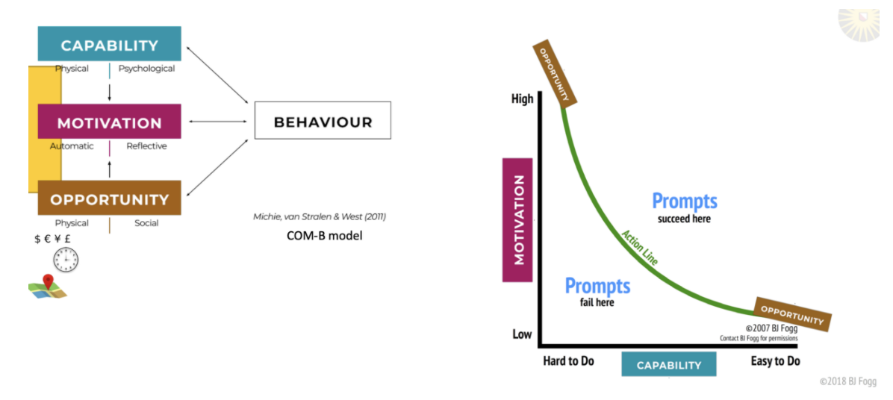
Norm activation theory
- Norms
  - Descriptive norms = what others actually do /not do, people actually have for those norms to be in force
- Injunctive norms
  - Objective social norms = what others think you ought to do /not do
- Personal norms
  - Introjected norms = what others think you ought to do /not do pride
- Integrated norm = woven in with values, feels meaningful
- The context determines which norms are salient (affecting thoughts and decisions)
- Awareness responsibility personal norm (via anticipated guilt and anticipated pride > pro-environment behaviour
- Measurement of awareness, responsibility, personal norms, and anticipated guilt and pride on a scale from e.g., 1 to 7
- For environmental communication: address either awareness, responsibility, anticipated pride by campaigns
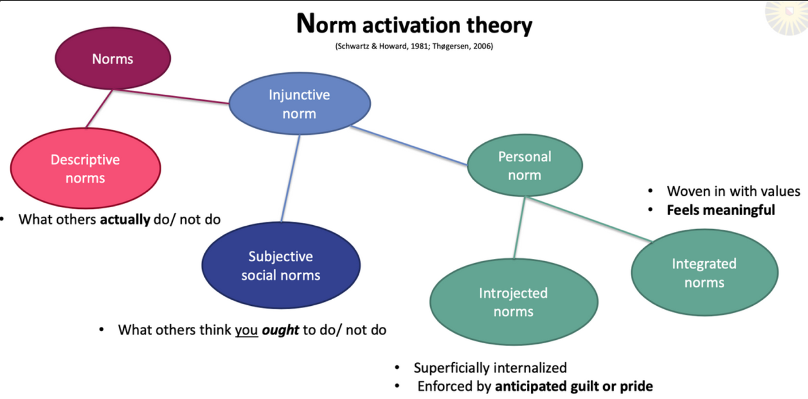

→ Mediation means that the relation between two factors can be **explained** through the mediator.
- asked questions to each of these
- anticipated guilt is a less strong predictor for PEB than anticipated pride!
- praise pratices or people that do these practices
- activating norms however is really difficult
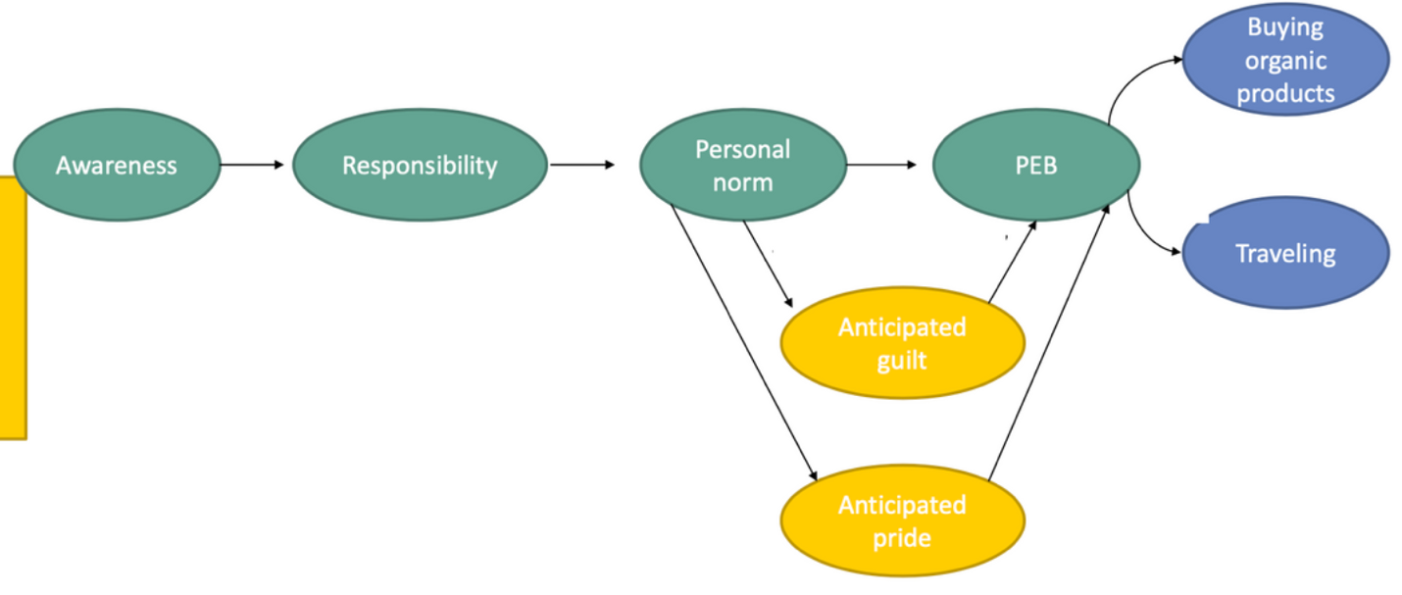

Phenomenological Communication Theory
Definition = Phenomenology is a philosophy of experience. For phenomenology the ultimate source of all meaning and value is the lived experience of human beings. All philosophical systems, scientific theories, or aesthetic judgments have the status of abstractions from the ebb and flow of the lived world.
Three principles of phenomenology
      - Knowledge is created through experience
→ you might know something, but if you don’t internalise it, then nothing happens with it
      - Meaning of things is connected to personal relevance
→ if it is not relevant to you, you will not remember it
      - Language transports meaning
e.g., X Ray fashion (virtual reality to understand production of cloth)

Theory of Planned Behaviour
- One of the most applied frameworks to predict behavioural intentions
- Used for tailoring interventions to target groups and barrier analysis
- Influence beliefs and salience, inform about consequences, use role models, provide feedback, tips and tricks
- Strong role of habits, habits influence intention (negative) and behaviour (positive)
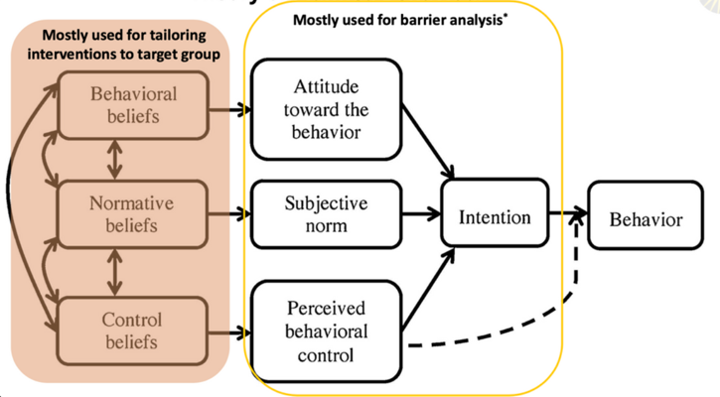
- Moderation
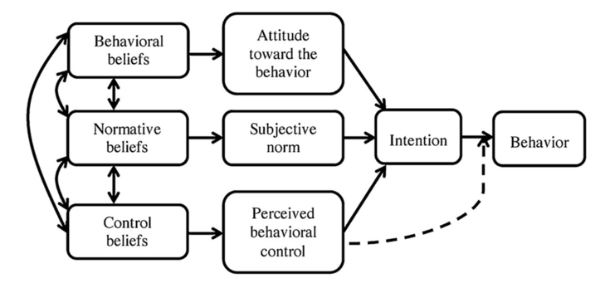

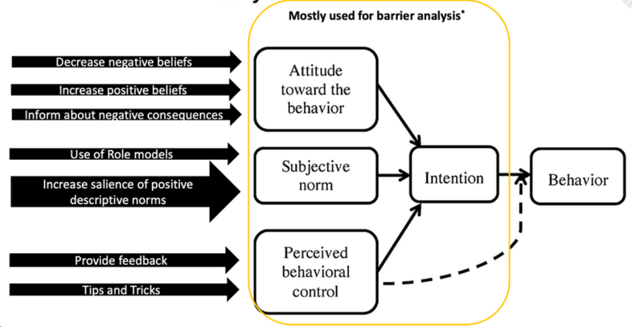
Habits:
→ Moderation means that the height of the moderating factor changes the relation between two other factors
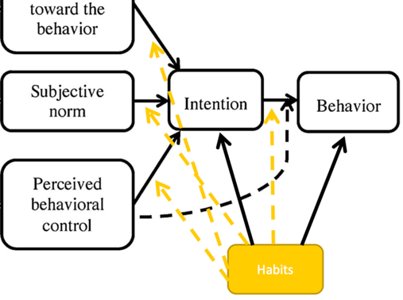
The role of habits:
Habits : Doing X is something that...
...I do frequently. ...I do without thinking. ...Is typically ‘me’.
Attitude toward the behaviour:
Subjective norm:
what do people in my social environment think about behaviour
Perceived behavioural control (PBC): how difficult is it for the person to perform the behaviour
Intention: how strong is the intention to switch of the light and how often does it actually happen
Self-reported behaviour: How often did you lately perform the behaviour

For low habits, intention was a good indicator for behaviour and a bad indicator for subjective norms
for high habits, intention was a bad indicator for behaviour and a better indicator for subjective norms
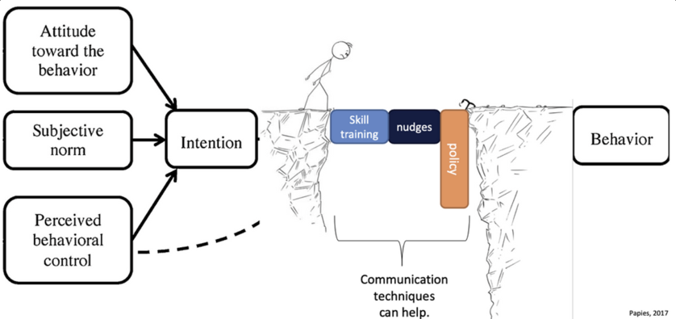
Intention behaviour gap
- Skill training
- Nudges
- policies

Principles of Persuasion
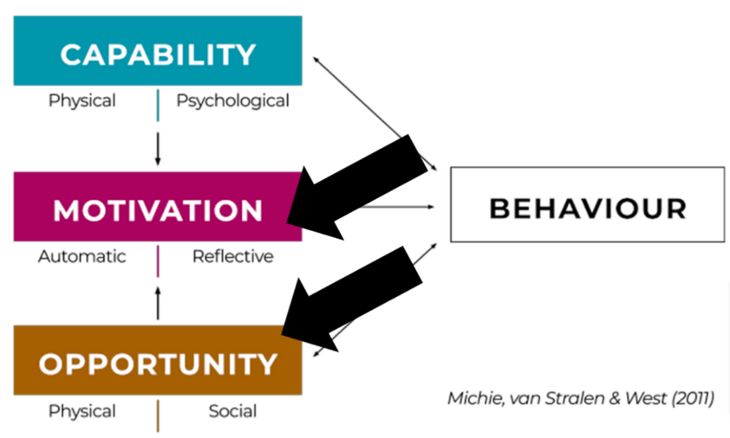
People systematically underestimate the influence of situational factors on their own behaviour and overestimate the influence on other people’s behaviour.
= “Third-person effect” (Perloff, 2009)

- Reciprocity
- Commitment
get people to write the desired action down
- Social proof
what you see other people do
- Liking
if you like the peron who is trying to persuade you to perform a behaviour
- Authority
- communicator has a authority in the field e.g. in the advert there is a dentist tells you to buy a certain toothpaste (experts, e.g., dentists in ads)
- Scarcity
- if people are afraid that they would miss out/presious/scarce, then people are more likely to (run out of products, limited editions)
- Unity (social in-group member conveys message)
that you want to belong to the group that the communicator is from (, e.g., people are more likely to understand if someone they believe in presents topic)
→ what is your target audience, what are their values, etc.

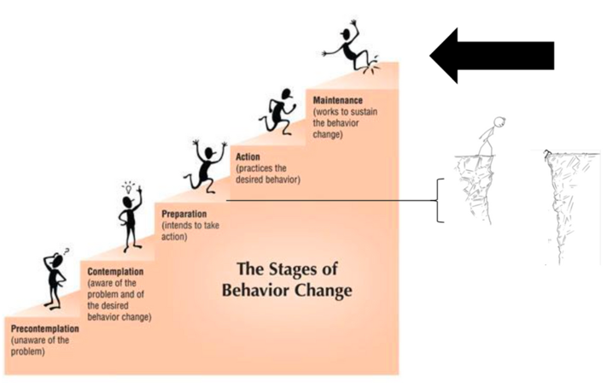
Stages of behaviour change
- Persuasion: determine where you have to ‘pick-up people’ pick up people from the bottom, but also give people that are already intersted the little dudge
- give people many, strong pro-arguments, while providing some small counter-argument

- Precontemplation
- Contemplation

Theory of Inoculation
- Know the counter arguments, own arguments prepared, how to respond
  - Psychological inoculation works by helping people build “mental antibodies” by briefly exposing them to a weakened persuasive message and thoroughly refuting it. The goal is to help individuals better recognize and resist similar misleading messages when they encounter them in the future
- Resilience against misinformation on social media
  - Emotion language
  - False dilemma
  - Incoherence
  - Scape coding
  - Blaming others
- Animations, good camera, emotional language … makes people watch
- Roozenbeek et al. 2020
- People understand better if they are engaged by inoculation (not reading for instance)
Conclusion
- Target (where on stage)
- How can we then influence this person’s behaviour?

Lecture 4 – Tabula Rasa

Aim: Behaviour change through communication
  - Create solutions for problems concerning behaviour
  - Positive behaviour change
  - Societal relevance
Set up communication strategies and intervention plans for municipalities or environmentally focused organisations, to bring these messages to the people
- Changing behaviour is not easy
- it can take a long time before you see any changes
- It takes a lot of effort to make these effect last over long period of time
- There are many conditions you have to take into account
- To prevent wasting time (and money) we therefore us an evidence base method to make sure our interventions are (very likely to work)

The rational human
- Traditionally interventions and communication are mostly focused on the rational person that makes well considered decisions.
- Traditional view
- BUT we aren’t that rational after all
  - A lot of behaviours happens automatically
Th irrational human
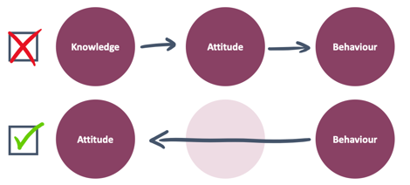
- Target behaviour and not the attitude
It is more effective to first target the behaviour to then change the attitude according to cognitive dissonance theory, in which you try to align your behaviour and attitude, once you practice different behaviour, your attitude will also change

Questions for development of a campaign
Q1: What behaviour do you want to change? Automatic vs. planned? (problem definition)
Q2: Who are involved in this behaviour? (target group analysis)
Q3: What influences this behaviour? ? (capacity, ability, motivation, … behavioural analysis)
Q4: Which interventions are likely to be most succesful?
BUT: note that these are not necessarily sequential steps, most often it is a kind of back and forth

Question 1: Problem definition
What behaviour do you want to change

Daniel Kahneman: Thinking, fast and slow
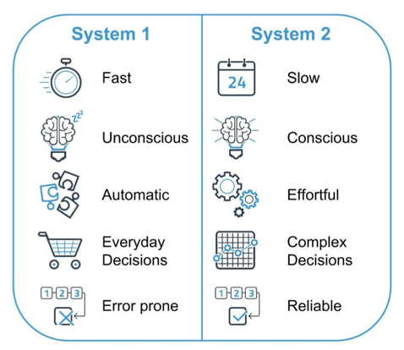
System 1
(fast, unconscious, automatic, everyday decisions, error prone)
  - we make fast decisions, so they are not really bias free
  - Makes up the majority of our everyday life decisions
  - Decision mased on heuristics (many = good; white coat = good) We rely on stereotypes
In communication
    - Little or no attention to content or arguments
    - Decisions based on heuristics (many = good; white coat = good)
    - Temporary change of attitudes and behaviour

System 2
  - We make complex decisions (these are very conscious decisions)
  - The types of decisions we make are more reable
  - BUT they require a lot moe cognitive effort
  - 1-5% of all behaviour
In communication
    - Attention to content
    - Critical evaluation of arguments
    - Rather a few solid arguments, than more with weak ones
    - Credible sources
    - More sustainable change of attitudes and behaviour

Influencing unconscious behaviour:
Disruptive automatic behaviour
- For example, connect the behaviour to an important date / decision e.g. the birth of a child, a job change
- Use and intervention that purposely breaks through normal behaviour patterns
- Make unconscious conscious with help of the fun theory
Nudging behaviour
= A nudge, is any aspect of the choice architecture that alters people's behaviour in a predictable way,
- gentle encouragements that make use of automatic behaviour, i.e., system 1
- No restrictions, regulations, no fines or money offered to people
- Change of the situation which makes it more likely that people will choose this
- Very effective if
  - people do not think about behaviour and if
  - The behaviour can be conducted immediately (nudge --> action)
- Examples of nudges:
  - Encouraging using the stairs by making them very visible or with signs to state the positive sporty effects of stairs
  - Pulling out paper towels is visually emptying out the rainforest
  - Size of the plate (people eat less if they have smaller plates)

- Different people react to campaigns differently but most people are strongly influenced by what other people do
- What often works: joining the in-group, joining the descriptive and conjunctive norms,

Influencing conscious behaviour
- Creating implementation intentions (if-then statements) work
- Plan/strategise/educate/facilitate by providing right tools for people for when they need to take decisions, that they then have all together to take that decision
- Influences through communication
  - Strong arguments
  - Take people seriously, no ‘cure distraction’
  - Start strong (when attention is highest)
  - Research possible resistance (third person effect)
- Third person effect (other people are more influenced by ads, than we ourselves)
- Examples
  - Tackling unemployment

3 Types of resistance to communication
- Inertia
  - it’s fine the way it is
- Scepticism
  - I'm not sure I believe you / your message
- Reactance
  - yeahh, no, I’m not going to do that/give that up
  - I’m happy the way I am

Question 2: Target group analysis
Target group analysis: Who are involved in this behaviour?

- Primary target group
  - Who displays this behaviour? Whose behaviour do we want to adjust?
- Secondary target group
  - Who supports (facilitators) or hinders (obstacles) the behaviour?
- Subdivision in subgroups?
  - e.g., based on age, income, education level
  - Influences media, language, … chosen different sub campaigns

- Sometimes the primary groups executing the behaviour isn't the best to target for effective communication
- e.g., rioting (prevent more people joining riots), NIX 18 (include parents, aim at parents)
- NIX 18 – parents have strong influence on their childre, so in order to change their drinking behaviour, campaigns can be focused on them
How?
- Scientific literature
- Statistical data
- Panels / focus groups
- Talks with stakeholders
Adjustment based on behavioural analysis
if you want to change people's behaviour, FIRST: Listen

Question 3: Behavioural analysis
What influences the behaviour?

Behaviour change wheel
- Susan Michie conducts a meta-analysis on behavioural interventions
- Conclusions
  - Few interventions are really evidence based
  - Interventions based on theoretical foundations are more often effective
- Behaviour analysis – Where does this behaviour come from?
- Determine interventions directions – In which ways can we change the behaviour?
- Work out interventions – What do we have to do to realize the interventions?
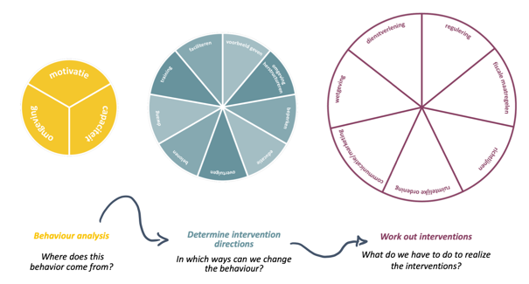
Behaviour Change Wheel: evidence-based alternative to development of interventions in practice

Behaviour analysis
- Personal Capability
  - Knowledge
  - Skills
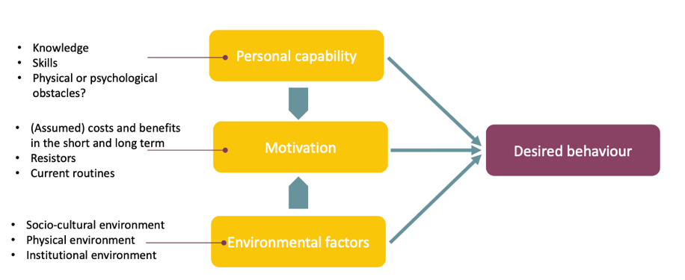
  - physical and psychological obstacles
- Motivation
  - Cost-benefit analysis on the long term
  - Resistors
  - Current routines + habits
- Environmental Factors
  - Socio-cultural environment
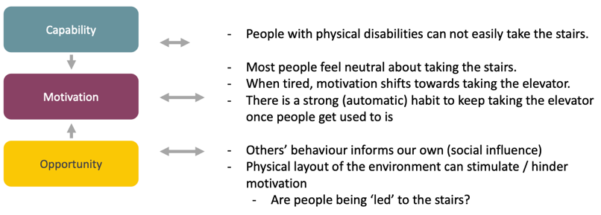
  - Physical environment
  - Institutional environment

Input
- Desk research (scientific literature, policy papers)
- 1 on 1 interviews with primary/or secondary target groups
- Observational studies
- Co-creation sessions (creating something together with the target group)
- Concept tests
- Quantitative consumer research

Question 4: Intervention directions
What intervention is most likely to be successful?
- Education – providing people with knowledge
- Persuasion – making it interesting/ attractive for people/giving strong arguments
- Restrictions – not allowing certain behaviours/ making it impossible to perform the right behaviour
- Environmental restructuring – making something more physically available and more visually appealing
- Modelling – showing a good example, role model; do not show how people are performing the ‘bad’ example, but give the ‘right/positive’ example and state how the majority is doing that
- Enablement – facilitating behaviour by providing with necessary tools or things to execute behaviour
- Incentivisation – people get a reward to engage in a certain type of a behaviour
- Coercion – forcing people to do something
- Training – skills
all these strategies have different time + practical implications

What is needed to create the most promising interventions?

- The step from strategy to execution is an important one:
- The outer ring provides insights into what ad who you might need for a successful implementation
  - Service provision
  - Regulation
  - Fiscal measures
  - Guidelines
  - Environmental / Social Planning
  - Communication/marketing
  - Legislation
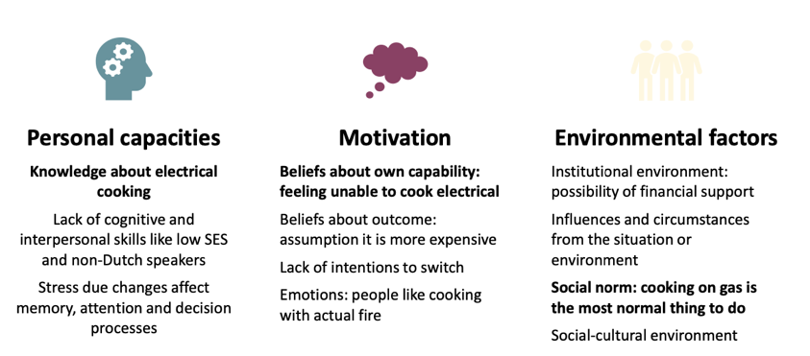
As a starting point: analyse the following dimension for your target group:
- Capacity
- Motivation
- Opportunity

Conclusion:
- Analyse relevant scientific (and other relevant) literature
- Get to know your target group (observe, interview)
- Analyse their behaviour
- Use a proven method to developing interventions
- always do (a) pre-test(s) and evaluate before executing (there is always soemthing that you haven’t been thinking of or undesired side effects)

How do you know of a campaign worked?
- Reach
- Feedback
- Statistics
- Broad societal markers
- Behavioural statistics
- Bread societal markers (from other research e.g., smoking/obesity prevalence

Lecture 5 – Acceptance and Resistance

Diffusion of innovation
- theory from 1962, has proven helpful in many contexts
- how technologies and social innovations spread
Processed by which:
1. an innovation (technology or new behaviour) is
2. communicated through channels
3. And adopted over time
4. By members of a social system
- Example: product, method, idea, service, ...

Five segments of adopters
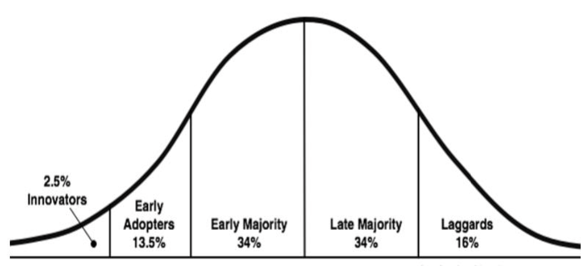
- Innovators: first adopters, risk taking
  - some people are very innovative supporting the development of the new technology and are very curious
  - Share experiences with friends and family
  - Usually well-educated + money
- Early adopters: need a bit of proof
  - Highly respected
  - They play a key role in chasm (= profound difference between people, viewpoints, feelings, etc.)
- Early majority: need some proof that the technology works, but are then happy to adopt
  - Take time
  - Observe
  - Only adopt if they are convinced
- Late majority: need much more proof,
  - Only when widely used + well tested before taking a risk, they are rather resistant
  - Peer and economic pressure
- Laggards: do not adopt or adopt late
  - and then there are some people that like to stay in their own habits and practices, are rather critical mindset
  - Highly resistant to change and sometimes never do
  - Minimal usage to social media
  - They can also be very well informed

you can have different roles for different innovations
- what is the population you want to change and who is it that you want to change?
you need to market to each adopter group specifically in another way, tailor your message to the group
- you need to make an analysis of each segment group, what kind of behaviour they have, what characteristics, think about what kind of communication ways do I have to target this group, when trying to change their behaviour
does not always need to be successful, some innovations get stuck in the chasm

S-shaped diffusion curve
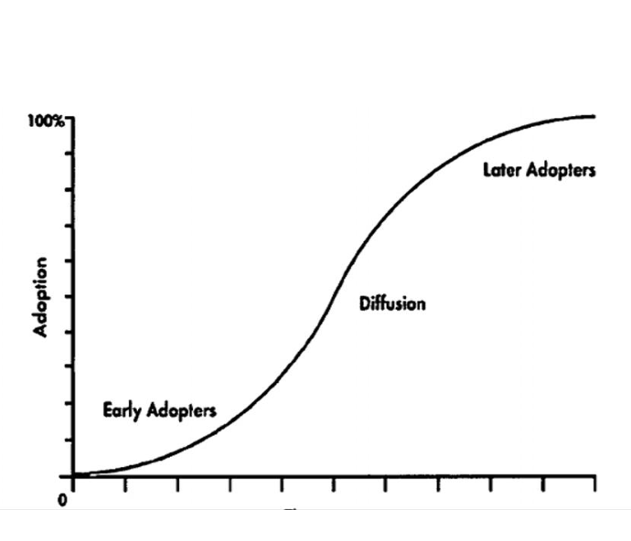
Chasm:
- Gap that needs to be overcome
- In between of early adaptors and early majority
- Risk at the beginning of an innovation
- Many innovations do not make it: were introduced by the early adopters, but then never took off (stuck in chasm)
- If innovations do make it:
  - The start is usually very slow
  - Then it might disperse and if early adopters are convinced, then it might take off
  - In the end it slows down again, because there is always a group that has either emotional or physical barriers that make them reluctant

Innovation decision process: 5 stages
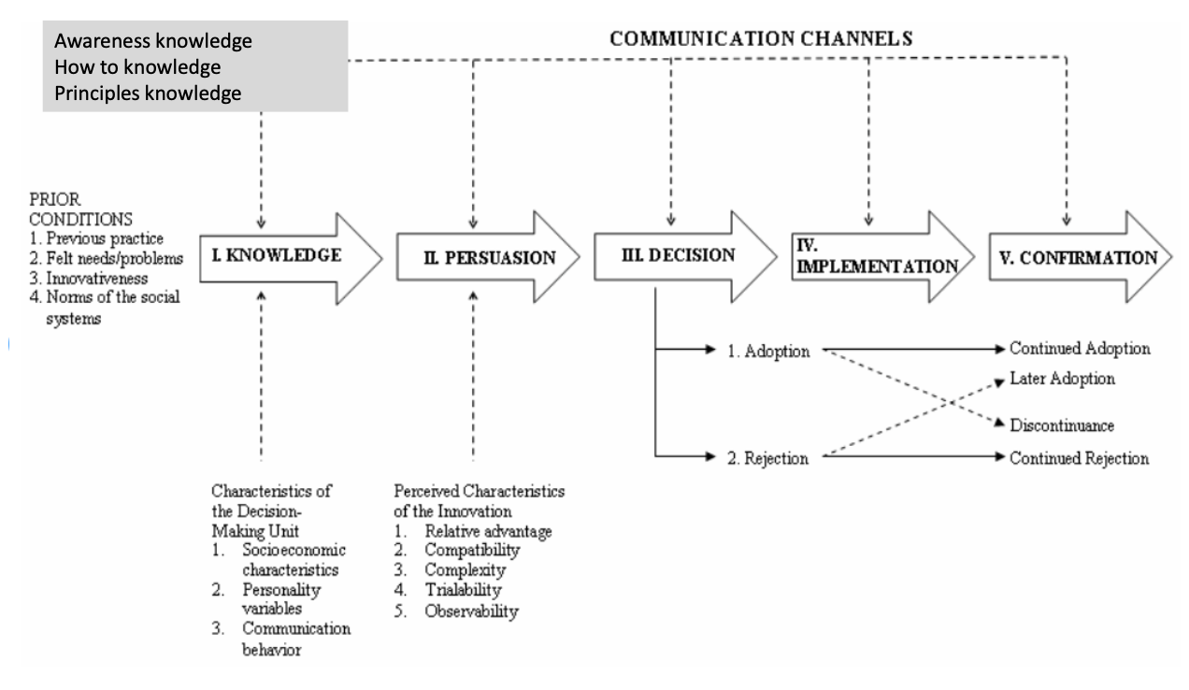
Knowledge:
- Awareness
- How to
- Principles: e.g., does it have an economic/ sustainability advantage?
Persuasion:
- Relative advantage - does it have advantages for me?
- Compatibility - Is it compatible with my systems in place, does it have advantages for me?
- Complexity - Is it easy to understand? Complex?
- Trialability - Can I try it upfront?
- Observability - What does my community do?
Decision:
- Two options: adoption or rejection
Implementation:
- You come about barriers once you implement and start adopting it; it might even be that you go back (barriers could be: money, convenience, infrastructure, …)
- OR it is easier than you thought and you rather immediately go into confirmation
Confirmation:
- If implementation is successful
- Becomes part of one’s life
not linear; people can go back to previous stages

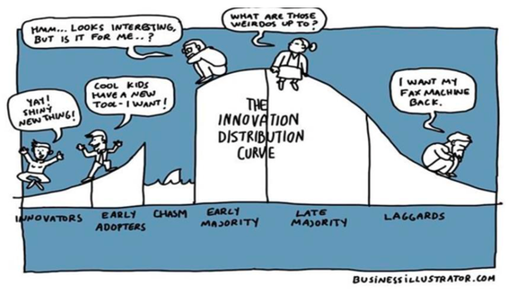
Weaknesses (Roger named them himself)
- Innovations often widen the social gap
  - Many innovations adopted by people who can afford them
  - e.g., talking of laggards is a strong normative statement, these are often people that simply cannot afford to adopt it if there are risks in play
  - Many of the new innovations have the possibility to take the risk, they can afford
- The theory has an innovation bias
  - As if every innovation is good, BUT there are quite some innovations that are everything else than good
  - Not every innovation is the change for better!
e.g., organic farmers in the 60s; seen as laggards, from today’s perspective we could say they were ultra-innovators (they were highly informed)
Forms of resistance
- Resistance is (active or passive) resistance to a change
- Reactance (negative reaction to feeling influenced, feeling like you have to do something, feeling curtailed in possibilities, perceived limitation of freedom)
  - e.g., ‘we always go by public transport’ who are you to tell me? There are a number of reasons why people do not
  - If we are told not to do something, a bit reflective reaction is to do exactly that
- Scepticism (distrust of the message(r))
  - Important to have a certain level of scepticism
  - e.g., climate deniers
- Inertia (no desire for change, not engaging)
  - Not interested, too much, so many other things going on
  - Also happens to people who would like to change
- NIMBY
  - Not in my backyard resistance
  - Willing to adopt as long as they are not affected
  - Difficult to tackle this one
  - Recent studies: most terrorism because of NIMBY
  - e.g., CO2 compensation, hydrogen storage
Reactance theory
Cognitive tension that arises when people feel that their freedom of choice is limited. They try to restore their freedom.
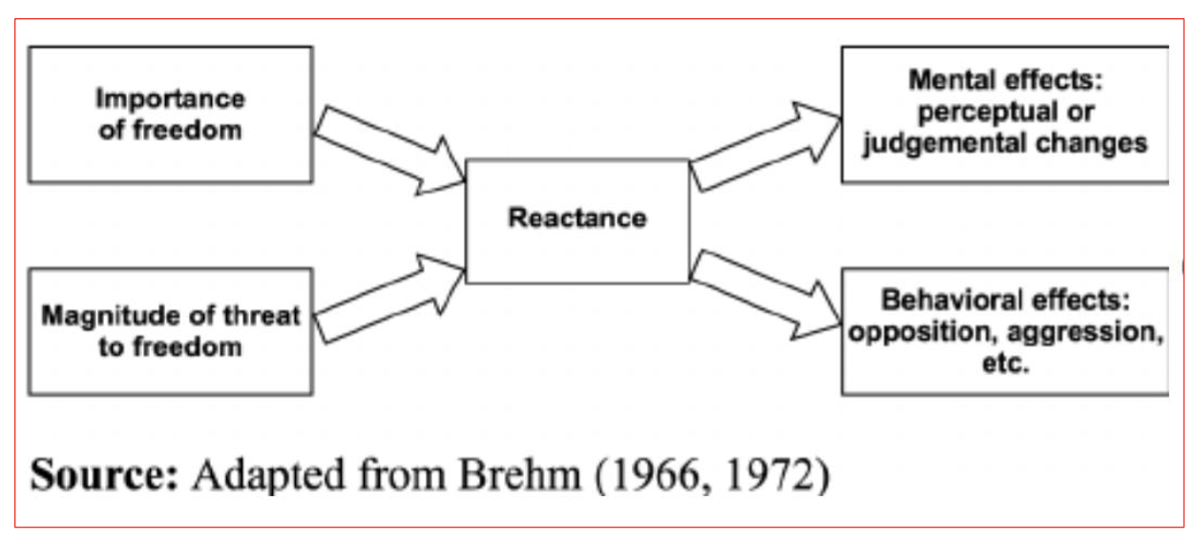
-> we highly appreciate our freedom
- the importance of freedom and how the potential threat is seen as limiting their freedom
-> how we perceive or how we judge the change
-> has behavioural effects towards this (are we angry or optimistic about it)

- If someone experiences reactance, this will have the following effects:
- The desire to engage in the very behaviour that is restricted
- The tendency will arise to encourage other people whose freedom is restricted to also engage in that behaviour.

Dealing with resistance: Change strategies
- Research and a clear assessment framework is needed to determine which route to change is promising under which conditions.
  - You need analysis before you start thinking about strategy -> often there is already some research done about that specific target group, gives you an idea about their reactions
  - Define target group, analysis of behaviour
- Map out what motivates the target audience and what could be a key ‘call to action’
  - Analyse the target group, motivations
  - What motivates their behaviour (change)? What pushes them to action?
- Don't assume that people will take action on their own.
  - They need to be pushed in a specific direction; they need to be helped to cross some barriers
- Handle as many (appropriate) strategies as possible side by side
  - They are usually no golden stand-alone strategies

Change strategy 1: Social Influence
Who do I belong to? What do they do/expect?
- Show what others are doing: descriptive norm
  - e.g., neighbours who have to panels
  - Social pressure and argumentation from your environment
- Indicate what is morally desirable: injunctive norm
  - e.g., “You don’t have solar panels?!?”
  - What are things that you should be doing/ what is morally desirable?
- Link the desired behaviour to the group to which one wants to belong
  - How will peer group react if I do that?
  - We are sensitive to peer reactions
- Link the undesirable behaviour to the group to which one does not want to belong
  - Again, linked to peer group
  - What is the peer groups norms? What is desirable and undesirable within that group?
  - e.g., also show people their peers who are adopting this new behaviour/technology
In short: play into social desirability
  - For analysis: know peer group

Change Strategy 2: New habits
What do I do automatically?
- Breaking through unwanted habits and routines
- Linking to transitions – using a window of opportunity
  - Bigger events in people's lives in which it is easier to change people's habits (anyways)
  - having children, moving = window of opportunity for incorporating new habits into everyday life
  - Or a crisis, a scandal
- Formulating implementation intentions
  - Get the target group to formulate their intentions
  - If you tell many people, it gets more difficult to not show the new behaviour
- Nudges
  - Give them pushes towards the habit you would like to archive
  - e.g., red lines in the library leading to the stairs

Change Strategy 3: Identity
Playing into to people's identity: who am I?
- Identity is strongly linked to what people do
  - How can you offer people alternative behaviours
  - e.g., vegan fake meat
  - How I define myself is very important
- Positive values that people are sensitive to can be linked to sustainable behaviour
- People are more likely to exhibit behaviours that suggest they are doing well
- In addition, people want to be consistent
  - Helps to tie oneself to intention by telling others
- Induce sustainable behaviour by indicating that it logically fits with their identity or social role
  - e.g. as a students, young person

Change Strategy 4: Emotions
Responding to emotions: what am I feeling?
- Playing into negative emotions (fear, regret, guilt).
  - Be careful with addressing fear, because it can lead to the opposite behaviour
  - Show loss and win, loss frame is stronger than the win frame (prefer to not loose 5€ over winning 10)
  - For example, people are sensitive to losses. But limited and with options to act
  - Show also what you can WIN
  - Even though the loss frame is more powerful than the win
- But people are more likely to do something if they enjoy it
  - Putting in something fun, laugh about, game
- Doing ‘the right thing’ leads to 'warm glow' effect

Change Strategy 5: Common sense
Common sense: what do I know? (knowledge)
- Properly informing people is one of the most basic ways to motivate them
  - BUT it depends on WHO your target population is
  - Some groups are more receptive than others
- But knowledge alone is almost never enough
- Combination with other strategies is needed
  - for example, make the costs of unsustainable behaviour transparent
  - Connect it to peer group or emotions

Change Strategy 6: Tangibility
Making the problem tangible: what do I notice/see/feel?
- Sustainability issues often remain abstract and vague to people
  - It becomes tangible when we see floodings or forest fires or vast diverse flouring fields
  - e.g., biodiversity crisis hard to see -> add symbols to it e.g., bees, polar bear
- Relationship with self and daily life is difficult
  - e.g., where can you see climate change in Utrecht, your neighbourhood, near community?
  - With time, things get less important quickly, e.g., hearing something about CC might affect someone today, but tomorrow the effect is already gone
- Name local consequences
  - Easier to understand and stay in touch with it
- Offer future prospects when action is taken
  - If people know that small things help, they are more willing to act

very difficult to deal with resistance, very slow process
you need a specific group, help them with stimulating target behaviours, each group needs their own stimulation
show them benefits, use champions for that (people how have proven very influential), be careful with choosing role models and with choosing examples (people how are always ahead of everyone, might not be a good example, because people cannot relate)
you need different strategies next to each other

Additional opportunities to reduce resistance
- Focus message on the behaviour and not the person
- Nudges and temptations instead of confrontations
- Emphasize freedom of choice (where possible)
- Preventively stirring up regret when rejecting the option
- List possible negative consequences
- Name scarcity of supply
- Deploying peers
- Visualizing the future and the possible contribution of the target group

Conclusion of today’s lecture
Bringing about change requires ex-ante analysis of your target group and how they might react to proposed change
  - Send out a small survey, focus group or so
  - Uninformed campaigns can even have unwanted negative effects
Each group (subgroups as distinguished by Rogers) requires different way of approaching
Resistance to change can come in different forms
  - Silent resistance
  - Communicate: what do people really think?
Be sensitive to signals of resistance and try to understand where they come from: which interests are at stake?
  - Costs? What are people loosing? What does the change cost?
  - Benefits? What do people win?
Think of different possible strategies to deal with resistance and combine them where possible/needed
  - There is always a certain combination of strategies needed

Lecture 6 – Developing Environmental Communication

Campaign ingredients
target behaviour, message, source, receiver, medium

Target behaviour
  - What behaviour are you aiming to change?
    - We often summarise under environmental behaviour, but there are large differences of trying to change one’s diet or to switch off the light
  - What type of behaviour is it?
  - Where does the behaviour take place? What is the context?
  - Driving forces of the behaviour? Inhibiting and facilitating factors?
    - What are the key predictors
    - Know your target behaviour
    - Find literature on exactly THAT

Message
  - If your target group is engaged influence them with strong arguments
  - If the target group has not yet taken standpoint give Counterarguments
    - Relates to inoculation theory = psychological/communication theory that explains how an attitude or belief can be protected against persuasion or influence in much the same way a body can be protected against disease
    - “even though biking is a little exhausting, it is a great way to exercise and stay healthy”
  - If the target group is not interested focus on arguments in favour
    - Do not use counterarguments here
  - Argument order
  - Frame for the message (see below)
    - Gain framing
    - Loss framing

Should you present the strongest arguments at the beginning or the end?
A strong argument at the beginning works best because:
- If the audience is engaged, they will process the arguments extensively from the beginning.
- Less engaged audiences tend to form judgements quickly and may drop out before the last argument is presented.
- (if you know your audience is engaged though, then in the end might indeed have slightly more effect)

Choose the right ' frame' for the message: the perspective from which a message is delivered.
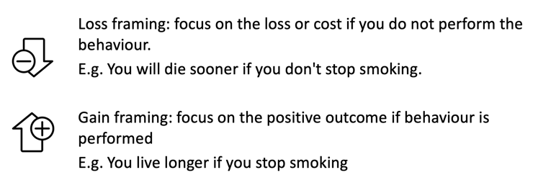
- give people discount when they bring their cup OR charge more if they don’t

When to use a gain frame and when to use a loss frame?
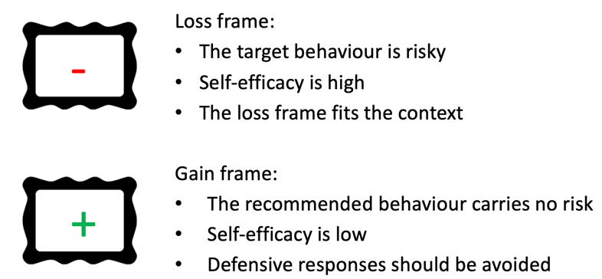
- Loss frame is often more effective as people prefer to avoid the loss over
- Loss feels bigger than the gain (people prefer not losing money over gain money)

Source
Who is delivering the message? Engagement with the messenger matters
- Reliability of the source: expertise and credibility
- Attractiveness only important for target groups that are not very engaged
- Sleeper effect: credible messages presented by an untrustworthy person
- It might convince you later when you remember the message but might have forgotten who was delivering the message
Receiver
The target group
- Experience
- Age
- intellect
- Self-control
- Need for cognition
- Self-monitoring
Need for cognition: the extent to which individuals are inclined towards effortful cognitive activities
- Check your need for cognition in this short online questionnaire: https://tinyurl.com/ekd2m6kr
- What does the recipient’s need for cognition mean for developing your campaign?
  - If they have a high need for cognition: let them come up with solutions, more background information, give them the opportunity to engage
- People in university often fall under very high ‘need for cognition’ so they need a little more context, be convinced, maybe include a riddle/indirect fun message that need thinking
Self-monitoring: the extent to which people monitor their self-presentations, expressive behaviour, and non-verbal affective displays
- High self-monitors: are aware of how others think about them and find this important
  - In an environmental campaign: work with peer pressure, social norms, …
  - People in this category have less stable attitudes
- Low self-monitors: are not concerned with how others think about them
  - Here benefits for self are better addressed

Medium
Communication based intervention techniques
- Direct communication between two or more people when all of them are present in the same situation;
- Person-to-person communication between two or more people which is mediated by a technological device;
- Communication via media: Books, Newspapers, Flyers, TV, Social media, Radio, Internet (website, videos). Posters, stickers, Prompts

Communication based intervention techniques

- Providing information
- Fear appeals
- Prompts
- Nudging
- Mere exposure
- Self-regulation
- Block leaders

Providing information
Information deficit model
Assumptions:
- inappropriate behaviour is a lack of knowledge.
- Instilling knowledge changes attitudes, and therefore behaviour.

Past assumption:
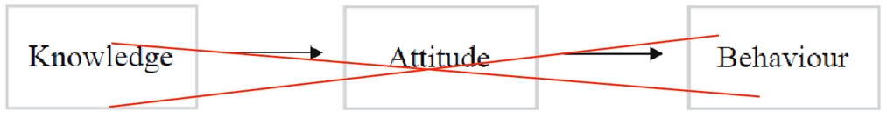

- Providing information is not very effective when the target audience is not very engaged with the topic
  - What are the believes people have
  - Where do they get their information from?
  - Is this a rightful source, can we help people to distinguish that?
- Knowledge gap: difference in knowledge between high and low educated
- Knowledge paradox: the influx of information increases misunderstandings about topics
- Information requires attention from the receiver. After all, knowledge has to be cognitively processed.
Influencing knowledge does not automatically lead to changes in attitude and/or behaviour!

Fear appeals
Persuasive messages designed to frighten people by reminding them of the dire consequences if they do not do what the message recommends.

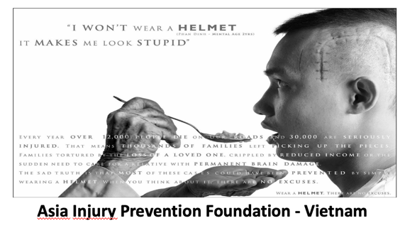

Are fear appeals effective? (own ideas from the lecture)
- Change it so that people can relate to it
- People often shut off themselves and do not want to think about the problem anymore
- Fear can be connotated to the maker of the campaign

Meta-analyses of studies on fear appeals conclude:
- Strong fear appeals result in high levels of perceived severity and perceived susceptibility (= state or fact of being likely to be influenced or harmed by a particular thing.) (Witte & Allen, 2000)
- Fear appeals have a positive effect on attitudes, intentions and behaviour (Tannenbaum et al., 2015)
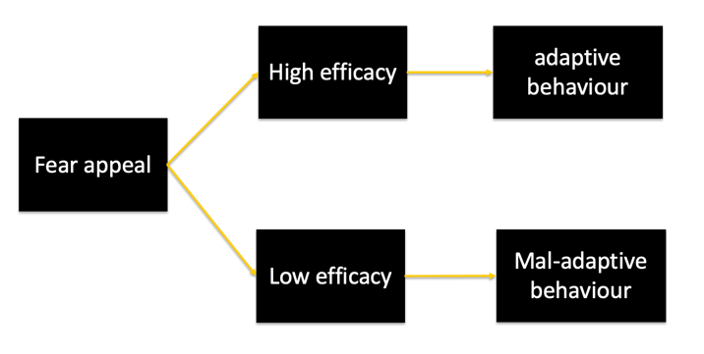

- Fear appeal often don’t give a directionality on what to do, then they are left only with fear this can then make them defensive and dis-engage
- It is very important to combine fear appeals when they are given with clear advice what to do

Fear appeals work best when combined with messages that increase self-efficacy
- Self-efficacy (whether the recipient can implement the recommended behaviour)
- Response efficacy (effectiveness of what is recommended)
- Adaptive actions such as acceptance of the message
- Mal-adaptive as defensive avoidance reactivity
It turns out that strong fear appeals and messages with high effectiveness produce the greatest behavioural change while strong fear appeals with low effectiveness messages produce the most defensive responses.

Prompts
A reminder of the target behaviour
Most effective in combination with reason for behaviour
e.g. switch off the light to save energy

Nudging
“A nudge is any aspect of the choice architecture that alters people's behaviour in a predictable way without forbidding any options or significantly changing their economic incentives” (Thaler & Sunstein, 2009)
Subtly influence on behaviour, without requiring the decision maker to make a conscious deliberate decision
Modifying choice structure, the environment and context of the choice, without requiring the agent to take a conscious, active decision
Movie
- The role of transparency
  - Ethics: manipulate people? Is it a right thing to do?
- Consequences of nudging
  - Spill over effects
  - Long term effects
- 4 core issues
  - Unresolved questions

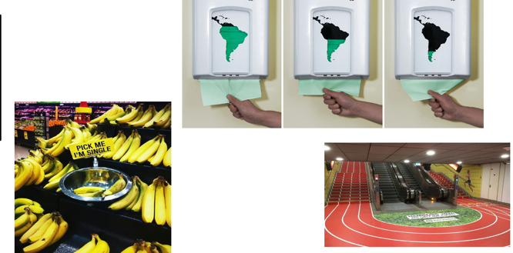

Mere exposure
- Repeated exposure to a stimulus leads to increasingly positive perceptions
  - If you see something more often, more times; then you tend to start liking it more
- Exposure to messages on stickers, posters, pencils, etc.
- Particularly effective in combination with positive associations
- But: only effective when the existing attitude is neutral or positive (NOT when negative)

Self-regulation
- Self-regulation: a process of conscious personal management, in which a person directs their own thoughts, behaviour and feelings to bring about a certain goal
- Stimulating self-awareness can increase self-regulation
- For example, through the presence of a mirror
- No evidence for this effect yet

Block Leaders
- Communication of norms/information through members of the social network of the target group
- Useful approach if other approaches fail for a hard-to-reach target group
- Behavioural effects tend to be more long-term compared to media campaigns

Target group segmentation

What is target group segmentation?
- Breaking down the overall target audience into groups so that information can be tailored to a specific audience
- It is applied when the target group is too large or when the differences between them are too great for a "one-size-fits-all" campaign

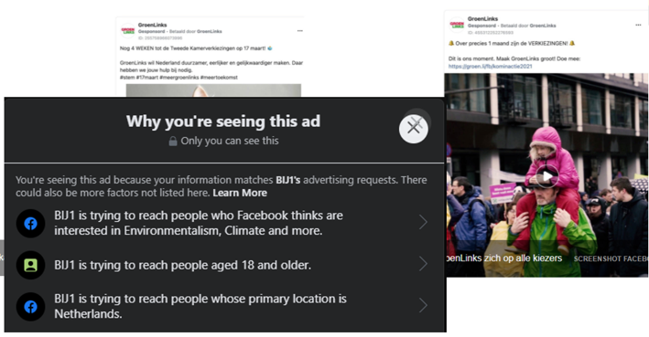

Why?
- Can help identify groups where environmental communication has the greatest impact
- It reduces the third-person effect
  - People always think it is ‘not them’ to be persuaded by the media
  - Targeting reduced this effect
- Provides the opportunity to tailor the information to the target audience, which can increase the persuasiveness of the message
- Reduce counter-effect of the campaign
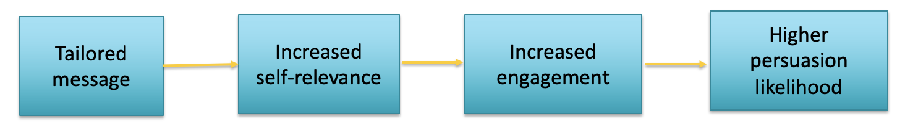

Different ways of target group segmentation:
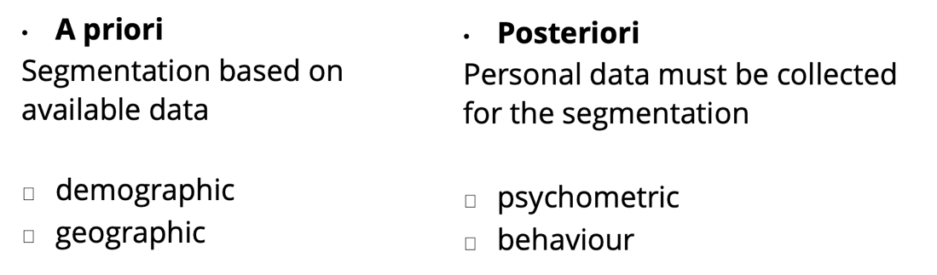
- When you already have the information about the target group vs. When you don’t

A priori segmentation
- Demographic
  - e.g., age, gender, education, income
  - Information often easy to obtain
  - Used as proxy for variables that predict behaviour
  - But relationship between demographic information and behaviour predictors are not always consistent – you often need some more information on the target group
  - Therefore, demographic information is not always

- Geographic
  - Segmentation based on the location where people live.
  - e.g., neighbourhood, city, region, country
  - It is assumed that people who live close to each other share common experiences, demographic characteristics and psychological profiles.

A posteriori
- Psychometric Segmentation
Segmentation by values: a desirable goal that varies in importance and functions as a principle in one's life
  - Guide us in our life’s, help us to make decisions
  - two dimensions of Schwart’s values:
    - Self-enhancement versus self-transcendence
    - Openness to change versus conservation
Values: a desirable goal that varies in importance and functions as a principle in one's life

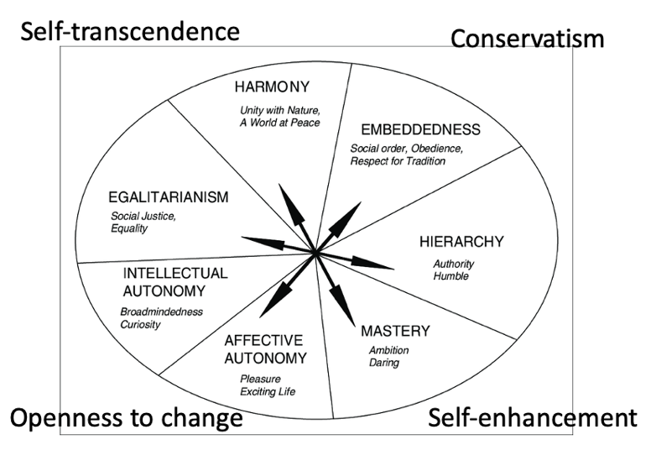
Different appeals for paper saving:

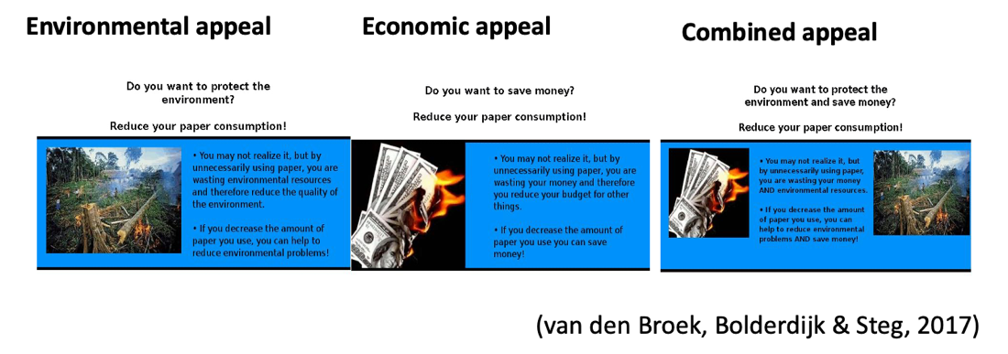
Values
- Biospheric values: care for the environment
- Egoistic values: care for yourself

How persuasive the message was depended on the prioritized values of the recipient:
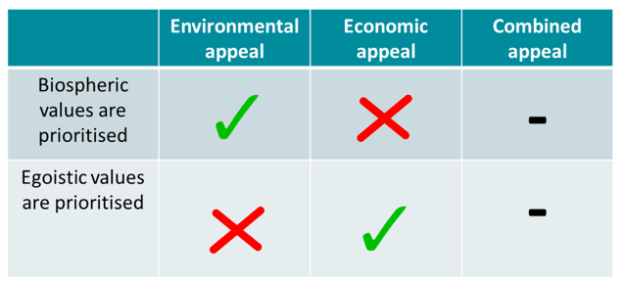
  - Results in line with values
  - combined appeal didn’t succeed! Only if there was a match between values and results
  - Knowing audience is important!

Segmentation by personality
Personality: more or less stable (over years), internal factors that make a person's behaviour consistent, and different from the behaviour of other people in similar situations
Big 5 Dimensions
- Openness to experiences (or intellect/Imagination)
  - Curious, adventurous
- Conscientiousness
  - Self-disciplined
- Extraversion
  - Sociable, talkative, high energy
- Agreeableness
  - Cooperate, trustworthy, want to help, using descriptive social norms saying others are doing that
- Neuroticism (or emotional stability)
  - Tendency to experience negative emotions
You can score high or low on each, these are dimensions
Important for campaigns, communicate tailored to the people
https://openpsychometrics.org/tests/IPIP-BFFM/

Segmentation based on activities, interests and opinions/attitudes.
E.g., food-related lifestyle segmentation (Nie & Zepeda, 2011) to predict organic or local food purchases
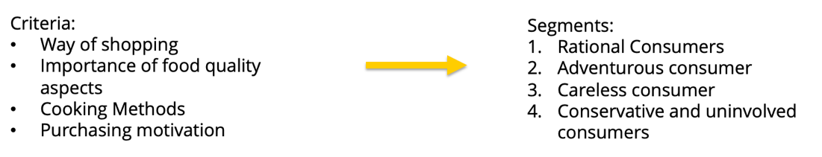

Segmentation by stages of Change
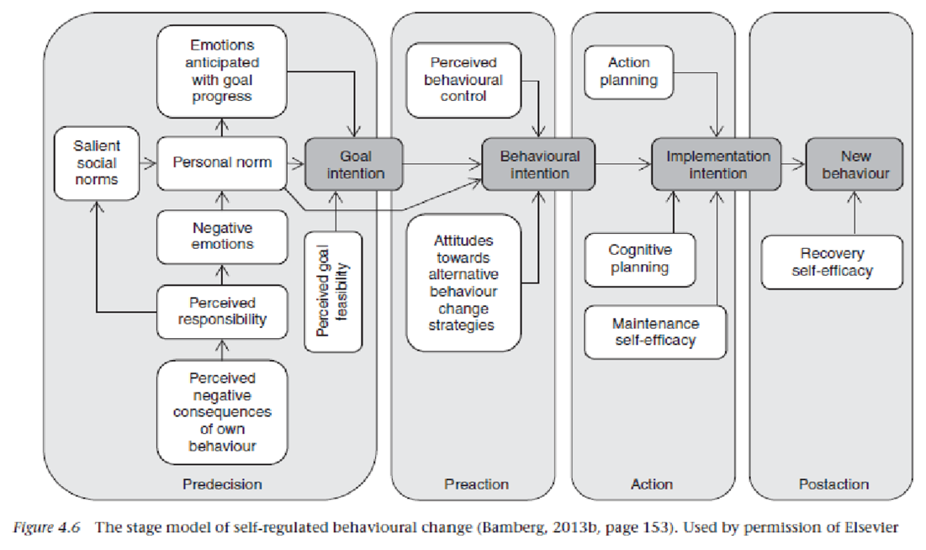
-> making it more and more concrete towards the goal

People at different stages of behaviour change should be targeted differently depending on the stage they are in
1. Research what stage your target audience is in
2. Identify the factors that can bring about change to the next stage
3. Focus communication on these factors.

How to measure in which stage they are in?:
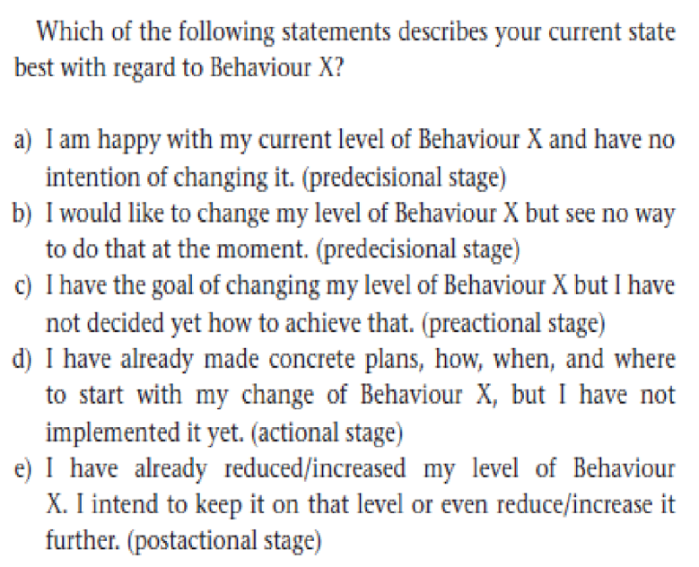

Segmentation by behaviour:
Behavioural Segmentation (see book)
Divide people in which behaviour they are performing:
- Information about purchasing behaviour or product usage is used to segment the target audience.
- One analyses what people spend their money or time on and clusters people with similar patterns regarding behavioural dimensions together.

Segmentations:
- Choice optimizers
- Economizers
- Premeditated shoppers
- Recreational shoppers
- Low-information seekers
- Support-seeking shoppers

  - Research your target group

  - Dynamic information technology
  - Combining segmentation approaches

- Lifestyle
- Phases of change

Lecture 7 – Brain, deciding & influencing

Choices
- Abstract, long term, yield? sustainable, climate neutral
- Concrete, right away, very nice! traditional

-> Our brain does not like abstract and far away in time, but concrete and soon:
-> Make things concrete, e.g., HOW do we buy cloths, HOW do we use electrical devices, …. --> focus on concrete visions, so that people can behave in a more sustainable way and make the right choices
-> Sometimes we do not have choices, we do not face sustainable choices (so many other things)

Solutions: how to persuade people
- Changing defaults (very useful)
  - e.g., advertisement:
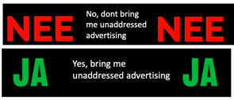
- Make something: visible + noticeable + recognisable
  - e.g., a red line that leads to the stairs, different colours, symbols
- Connect the unwanted behaviour to something annoying
- Guidelines

Ethical consideration
- Depending on how you produce and sell your car, people will drive more or less safe, risking their life based on what you are offering them THIS is the same with Climate change and non-sustainable or sustainable choices

- adaptation of behaviour to circumstances; in a house with energy label A almost the same energy is uses as in a badly insulated house

- The way you present the information to people will influence the behaviour that people will base their choices on

- Our brain, in situations where our brain does not know what is expected, is very much determined by the circumstances
- Just a little help for the brain: Colours and shapes make it easier to distinguish

How the brain works
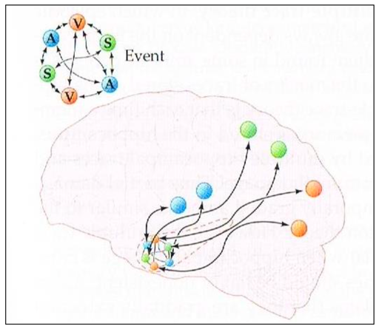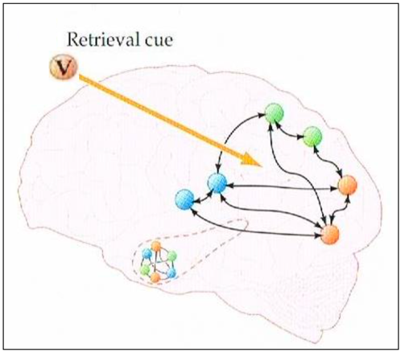
V = visual
A = auditive
S = Sensible (everything you feel)
-> together, V, A, and S create a unique network, recognisable
Parts of the brain involved:
- Hippocampus
- Cortex

Bad campaign:
- Focuses on the UNwanted behaviour
- Your brain sees these social media symbols and then causes people to wanting to check their social media, so then the CONTRARY is achieved
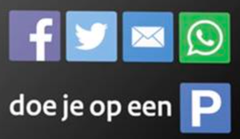

Good campaign:
- Focuses on wanted behaviour
- e.g., On the street I am offline!

How do we hear + see?
- We make a combination of what we hear and what we see
- We see with our eyes as well
- Not only depends on WHAT you say, but also how much we believe them depending on how we perceive their expertise (clothing, background trustworthy, who is the right person to be trustworthy)
Example: presentation
- Find out information about target group
- How to say something?
- Who is giving the presentation?
-> we hear with our eyes
-> avoid conflicting signals, (e.g., huisdoktor) focus on wanted behaviour, stay away from fears

Emotions are in charge!
- Emotion is the boss in our brain and sustainability is not so important for individuals!
- We make choices with emotions: Pain, Fear, Profit, Social bonding, … (like in old times)
  - When doing campaigns: try to address those underlying feelings and emotions
  - Pair facts with consequences to trigger emotions
- Habitual behaviour
- Difficulty with abstraction, long term, complexity, extreme consequences
  - We prefer easy and short-term choices
  - Frame problems as simple as possible, name causes and solutions, e.g., ozone hole
- Difficulty with lack of own influence, insufficient action perspective, free riders
  - We perceive that most people don’t do something
-> some people do change their behaviour because of identity
-> if your identity has to do with sustainability, then it is logical that you also show it in the choices that you make you want to be consistent in the choices that you make
-> government should help us to do sustainable decisions UNconsciously -> make sustainable decisions the easiest and fairest
-> post rationalisation: when they take the sustainable decision, then they get a reminder that they took this behaviour, so that they integrate this behaviour and ‘sustainable’ into their identity

Working method designing smart measures
-> finding the right measures + effective interventions that develop the targeted behaviour
1. Objective (goal, target group, target behaviour!)
2. Analysis (context, motives, constraints)
3. Intervention (develop your measure: what is it, how, when, etc.)
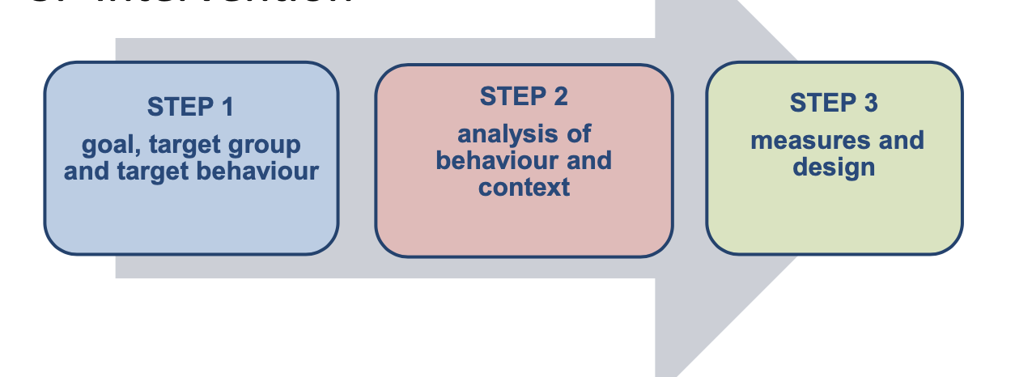

Format for finding effective interventions

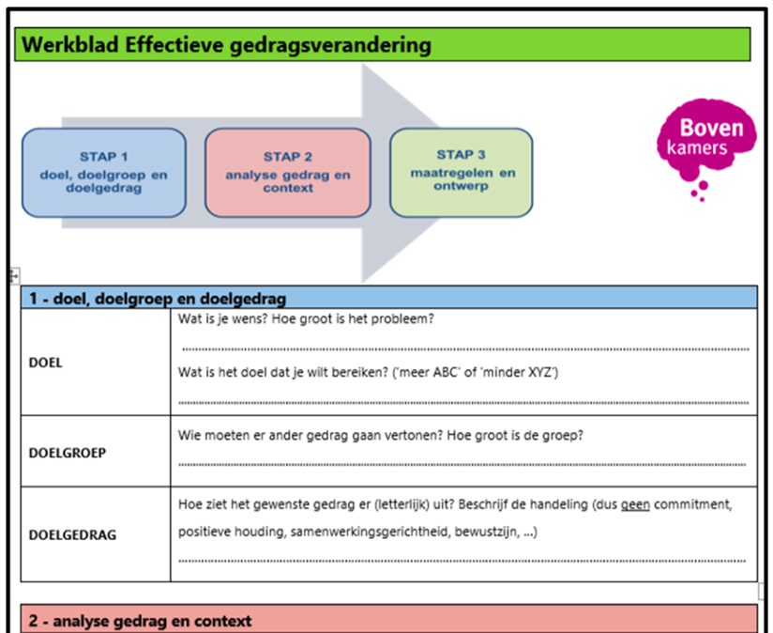--> on BB in full and English

Example: Design Healthy behaviour in Beurskwartier Utrecht
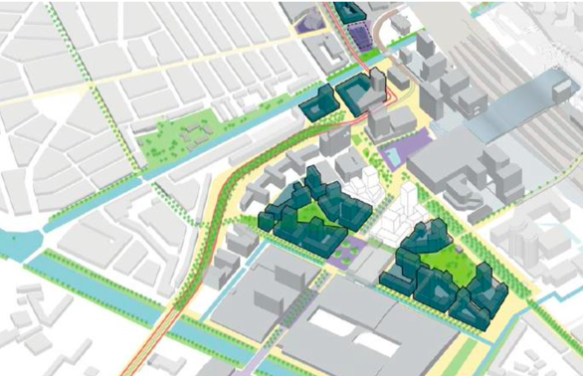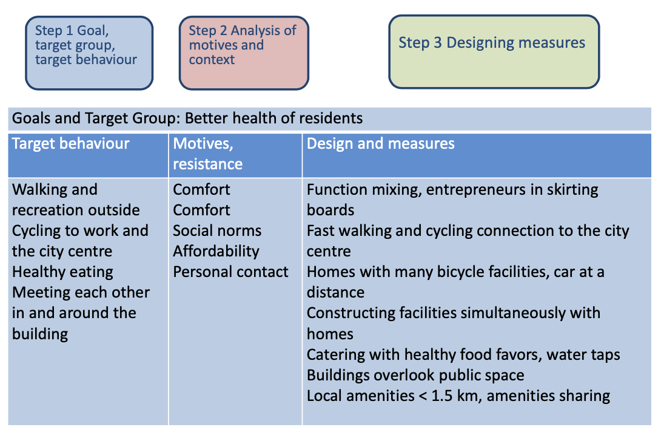

Two types of choices:
- Rational conscious decisions
  - Use facts and knowledge
  - Only 5% of all choices, or less than 1% -> small fraction of all choices
- Automatic unconscious decisions
- For unconscious, automatic choices this won’t work
so it makes sense that when we overthink our behaviour, THEN only we start to use facts and knowledge

Traditional approach to behavioural change:
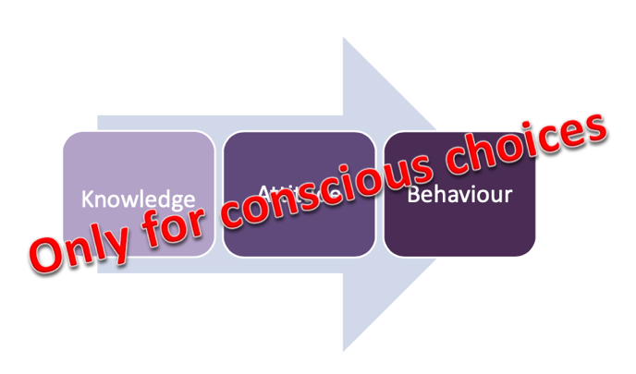

For both conscious and unconscious choices: Direct control of desired behaviour:
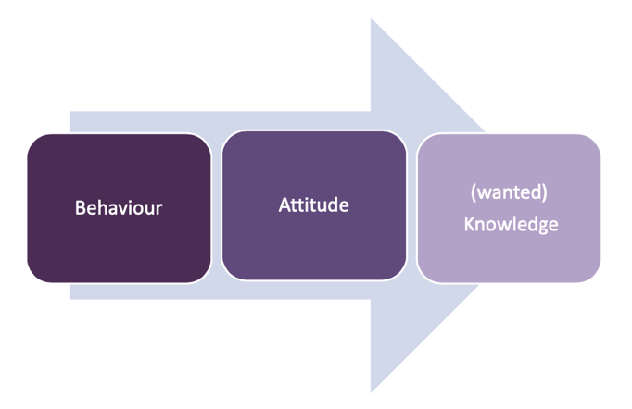

Direct focus on behaviour
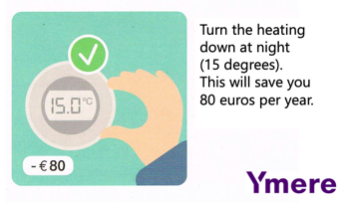
works for a specific target group (for people that consider 80€ a lot)
you don’t give reasons, don't talk about climate change, but JUST focus on behaviour

Looking strategically at your assignment:
View your assignments from multiple angles, especially from the user's experience and target behaviour
- from diverse perspectives, but especially from the target groups perspectives

3 keys for influencing behaviour
1. Moments of change
- When people make a conscious choice (arguments and knowledge can therefore be used)
- Periodical or designed or spontaneous (e.g. when moving, initiated by the government or ‘unplanned’ sporadic events)
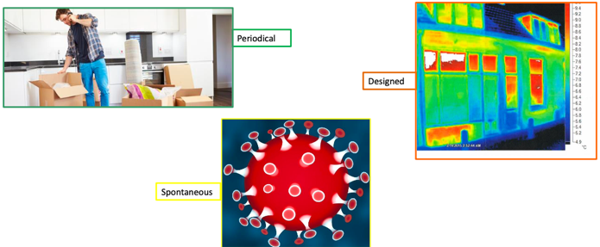
- e.g., moments of change at university: beginning of the year, beginning of a new period, new building, new workers, seasons, new people, new situations
- Risk: overload of input at the beginning of new life chapters
--> Arguments and knowledge -> should only be used in moments of change

2. Principles of behaviour
People are sensitive to ...
- Social norms
  - e.g., here we are smoke free, your neighbourhood does the same
- Sympathy
  - If you like someone, you are willing to do more for a person
  - Address people with names
- Authority, expert of your target group
  - Target group specific
- Consistence
  - Focus on someone’s identity and uses pieces that people already implement in their life
  - Check inconsistency, then agree to ‘Let’s do it the way you already promised’
- Anecdotal information
  - Story of one person, narrative -> story telling
  - It triggers emotions
  - Easier to relate to it
    - e.g., display example people that the target group people can relate to, similar life situation, lives in same area, has same job
- Profit and loss
  - Compliment, rewards, punishments, …
-> for specific target groups some of these are most important! Focus on a few of them for a campaign!

3. Resistance reduction
- Resistance follows from preventing loss
- Always works: Remove unnecessary barriers:
Make it easy. Every extra step is a drop-out moment
Resistance towards windmills:
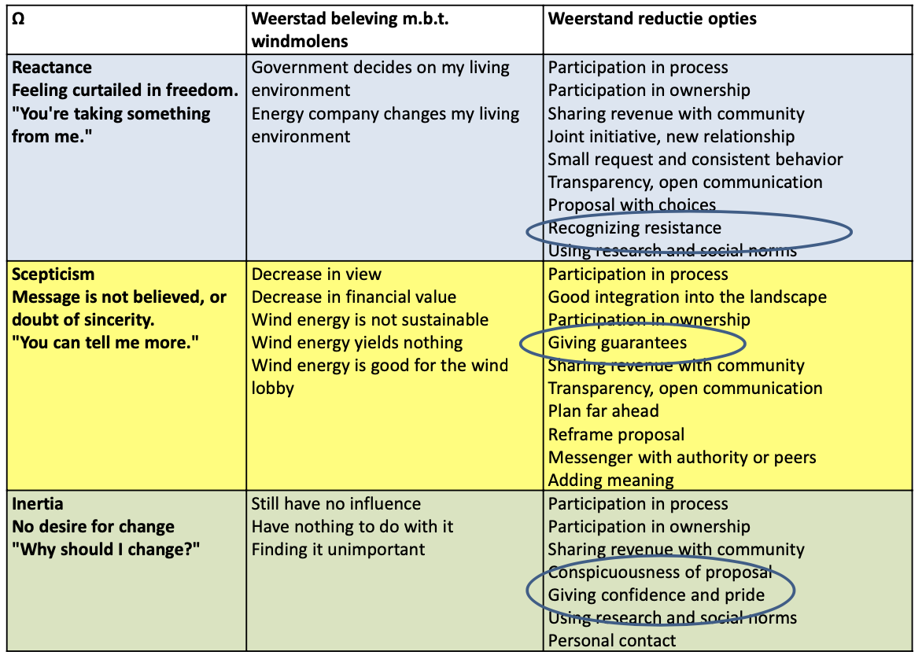
Use the target behaviour !!

Lecture 8 – Environmental Communication with groups - Games

Individuals, households, groups

Individual decisions
- No others are directly involved
- Social aspects still need to be considered, anyway
- Many are unconscious
Household decisions
- Joint decision-making
- Who has most influence?
  - Dependent on culture etc.
  - Children have more influence than one might think
- Individuals in the household can use many strategies to influence the others

Group decisions
- 2+ people
- Same goal, experiences, purpose
- Group roles: expectation of what the person does in relation to other group members
- Group norms: shared beliefs about appropriate behaviour, attitudes, and perceptions of all group members

Group processes
False consensus
- To see one's own behavioural choices and judgments as relatively common and appropriate [..] while viewing alternative responses as uncommon Ross et al. (1977)
- e.g., political party, elections (green bubble)

Diffusion of responsibility
- Diffusion of responsibility: when it is unclear in a group who bears the responsibility to take action
- Diffusion of responsibility can cause bystander effect:
  - individuals are less likely to take action if many people are present
  - Because people do not know who is responsible, less people are likely to take action
  - You are less likely to provide assistance when you are surrounded by many people
  - Attribution: study of how people explain cause and effect
  - ‘Someone else will do it’
  - Brain development, norms, … play a role
Knowledge about the bystander effect helps making better decisions
  - Extraverts more likely to be immune against bystander effect (they do act)
  - Overcome: by assigning tasks
Group norms
- Reduces uncertainty about group members’ behaviours
- Mechanisms of enforcement: peer pressure, social exclusion, social cohesion

Development of group norms
- A powerful member of the group makes an explicit statement
  - e.g., covid, within the social group one person that took decisions ‘we are/are not gonna meet’, which then sets the tone
- Norms are set and defined by the group after a critical event
  - e.g., sexual harassment
  - You develop the group norms together while responding to a critical event
- The first behaviour pattern that emerges in a group becomes the standard
  - e.g., first lecture
- Prior group experiences inform current group norms
  - Change something or continue in the same way

Majority influence
- The majority of group members often have the largest impact
  - But that does not mean that people cannot change their mind
  - you might adopt your opinion, so that you fit in
- Majority standpoint can lead to conformity
  - This is probably not the deep processing kind of decision making, but might still be processed via the central route
- Minority standpoint can lead to private acceptance
  - (private acceptance = a personal attitude change and the result of conformity)
  - This is influenced by the central route and involved deep thinking
- Asch experiment
  - People conform to group
  - We are aware of what people around us do and belief
  - We want to belong to group and fit in
  - Relevant for CC denial
  - Personality type: agreeableness
  - Dependent on how well you know groups
    - Group norm: If it is okay to disagree, people are more likely to disagree
    - If people are more similar, they are more likely to agree

Social identity
- Group membership is important to people’s self-concept/identity
- In-group members are perceived more favourably and more alike
- Out-group members are perceived as less positive and more different from oneself
  - Many studies that if you put a lot of people in group, and you are told before that you have something with them in common, then you tend to like them better than if you are told they are different to you (even favourite colour works as common feature to consider others in-group)
  - e.g., high school, football stadium

Group polarisation
- When a group’s decision is more extreme than what each individual member’s decision would have been
- Group polarisation can result in a risky shift: the tendency for more risk-seeking behaviour after a group discussion
- e.g., if you ask a board of a company a decision where to invest, they might make a decision ahead that is quite mitigated, but then if they are in a group, they are more likely to take more risky investments

Why?
- Diffusion of responsibility
- Persuasive argument theory
- Interpersonal comparison theory
  - People want to be accepted and therefore conform with the majority of the group
- Social identification theory

Group interventions to change behaviour

Group competition
Assumes that identification with a group will motivate members to do better than other groups to enhance the status of the group
- You want to outcompete the others
- Observing other member’s efforts may reinforce individual effort
Can reduce social loafing, enhance efficiency, corporation in the group and creativity.
- Social loafing = It's what happens when someone puts in less effort when they're judged as part of a group. This level of effort is lower compared to when the same person is working alone or judged individually

Group feedback
- Provide a group with feedback on their performance on the environmental behaviour in comparison to other groups
  - Energy saving campaigns, you can enrol household to an energy saving competition, and will be effective because they feel they are in it together
- Can stimulate group competition
- Individual contributions cannot be traced, which may reduce the effectiveness of the feedback

Participatory interventions
- The group-members create or tailor the intervention for their own group, supported by the researcher
- Reduces the risk of resistance to the intervention
- Some group members can become an influencing minority
  - Make sure the intervention lands well with the target group

Personal communication
Representatives of a public organisation engage in personal contact with members of the target group (stakeholders) who are given the opportunity to respond.
e.g., many city councils do that
But what often happens is that people show up that are quite strongly against or in favour, most likely against not representatives
Aims:
- to inform stakeholders,
- discuss with stakeholders,
- have stakeholder participate in the development of plans,
- or influence their attitudes or behaviour.

Q&A

Rhetoric
Logos (logic of the argument, evidence)
- You have to be consistent with your argument, step by step
- Check with logical fallacies (poster from philosophy course here)
- ALWAYS back up with data (to convince the critical)
Ethos (credibility of the message sender)
- Different for each receiver
- Who is the sender and why is the sender credible? Why do you trust the sender?
- e.g., IPCC, grandma, smart classmate
Pathos (involvement of audience)
- Use of metaphors
- The audience that they have the feeling like they are engaged /can contribute something
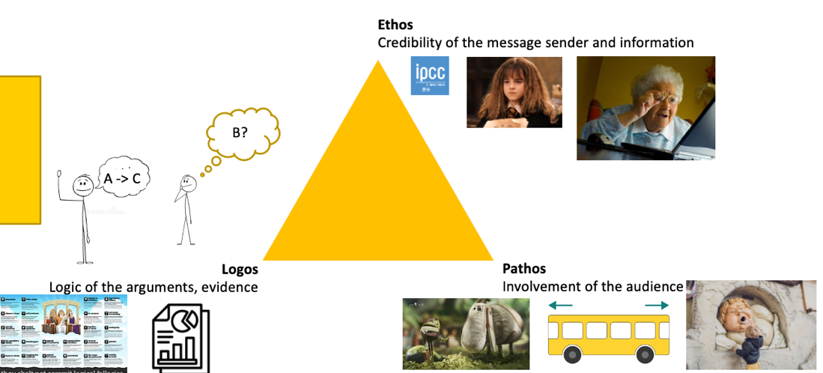

Schwartz values
- Each individual has their own composition
- Values influence attitudes, preferences, behaviours
- Values can compete

- Each individual has their own composition.
- Values influence attitudes, preferences and overt behaviours
Sagiv, L., Roccas, S., Cieciuch, J., & Schwartz, S. H. (2017). Personal values in human life. Nature human behaviour, 1(9), 630-639.
- When multiple values compete in a decision à the combined strength in favouror against determines the outcome.
- The grey circle represents the person’s average value strength.

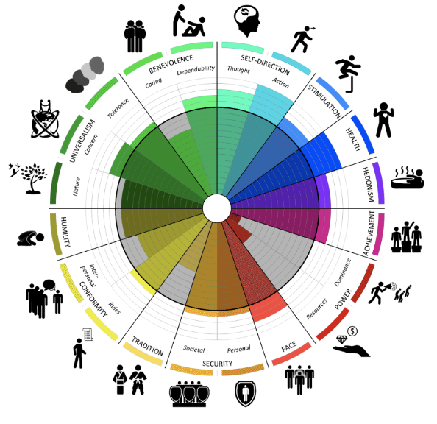

Behaviour Change Wheel
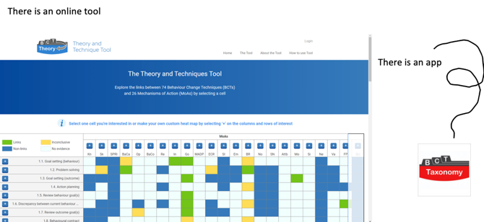
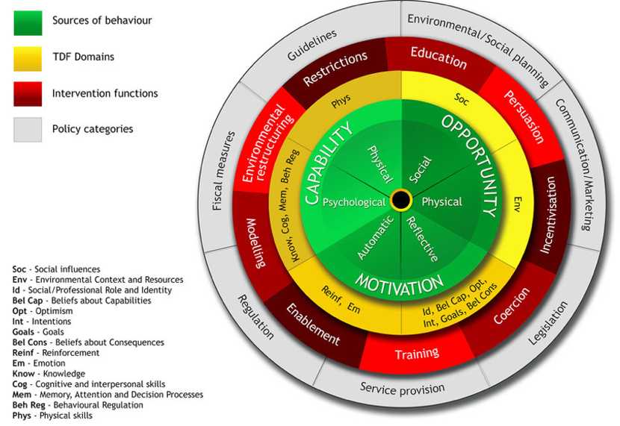

online tool and app

Questions:

Difference self-identity and personality:
Self-identity : something is very part of you, social identity, who are you in relation to your immediate peers, what is the consistent element of YOU across different situation, what you think of yourself
- Personality can become self-identity if you are often told that you have this type of personality
Personality: the type of behaviours that are similar across different situations, e.g., extraverted, personal traits, observable by others, traits, broad
There can be an overlap between those two

Prompts are types of nudges:
- Prompts are the last reminder,
- often gives you a text, very simple
- Prompts are a little more conscious
BUT, Nudges also do not necessarily have to be unconsciously

Representative heuristics
- You are inferring how representative something is from how often you hear about it
e.g., when just recently a plane has crushed, then you aer more likely to estimate that that is non a rarity even though it is actually

How much to go in depth with the book:
- Theories, their components, examples

EXAM:
- 20th of December, 11:00-13:00, EDUC-Alpha & 11:00-13:30, Ruppert 029
- All the literature and lecture materials must be studied for the exam.
- The exam consists of multiple-choice and essay questions.
- If you are not able to make it to the first exam due to circumstances beyond your control, notify the course coordinator with proof (please email Luka l.e.biemond@uu.nl).
  - The resit takes place on the 7th of March, Ruppert 038
  - The exam will count towards 50% of your final mark, you can compensate a failed exam with the coursework
  - You can only resit the exam if your mark is between 4 and 5.5

Answering Multiple choice questions
- Start by answering questions you know the answer to
- Then answer the questions that are easier to answer after you filled in the easy ones.
- Then move on to the questions that are difficult to answer
- If you have time left, review every answer again (especially the difficult ones) and check that you haven't made any mistakes.
- Don't guess, eliminate answers that are incorrect

Answering open questions:
- Write an outline of your answer first
- If you have no idea where to start, start by writing on a scrap sheet, this can jog your memory
- Write as clearly and concisely as possible

Test yourself:
- Review the questions at the end of each chapter in Klockner
- Test your knowledge with the sample questions on blackboard (will follow soon)
- Test each other’s knowledge

